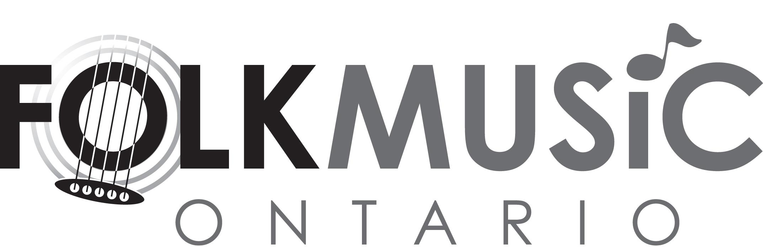

BOARD OF DIRECTORS - NOMINATION FORM
COMPLETE FORM AND SUBMIT WITH ALL ATTACHMENTS TO FMOnominations@gmail.com

NOMINEE:

Telephone: ( ) Email:

Nominators (must be members of Folk Music Ontario):

NAME | TELEPHONE/EMAIL | CONFIRMED SUPPORT  (VERBAL OR WRITTEN)
1.
2.
3.

Brief bio (100-150 words) of nominee (if applicable, this will be published as part of the election process; attach electronically, if possible):

Why nominee would make a good director (100-150 words) (if applicable, this will be published as part of the election process; attach electronically, if possible):

I have read the “What to Expect If You Are Elected” document and hereby agree to take part in the nomination process.

Nominee: Date:

